ASSIGNMENT NO 1

Name Simran Iftikhar
REG NO. L1F24BSCS0675
SUBJECT DBMS

ERD:

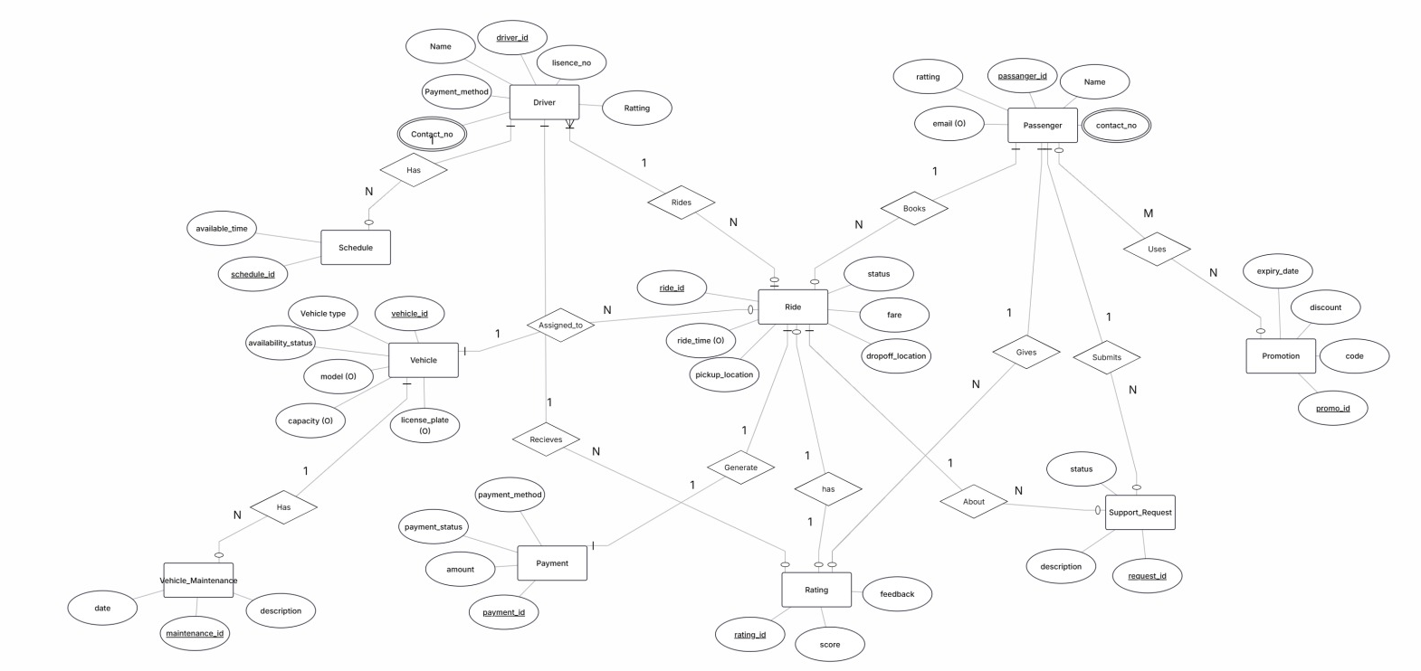

Rational Schema:

